Comparisons to analytic solution for simple wedge

Sean Reilly - 16 September 2015

WaveQ3D needs a testing benchmark that clearly demonstrates 3-D effects in transmission loss. This whitepaper derives an analytic solution for acoustic transmission loss in the wedge-shaped, 3-D ocean environment illustrated in Figure 1. We examine a scenario in which receivers are at the same distance from the wedge apex as the source, but offset in range across the slope. In an 2-D model, these receivers appear to exist in an environment of constant depth. Because the 3-D solution horizontally refracts acoustic energy down the slope, the 3-D solution has higher transmission loss as a function of range across the slope than the 2-D model. This difference provides a benchmark that clearly demonstrates 3-D transmission loss effects.

# Derivation of analytic solutions

Figure 1 defines the wedge geometry in Cartesian coordinates:

$α_{w}$ = angle of the wedge relative to the horizontal;

$x_{s}, x_{r}$ = range of this source and receiver from the wedge apex along the ocean surface;

$z_{s}, z_{r}$ = depth of this source and receiver down from the ocean surface; and

$y_{r}$ = cross-slope distance of the receiver relative the vertical source/origin plane.

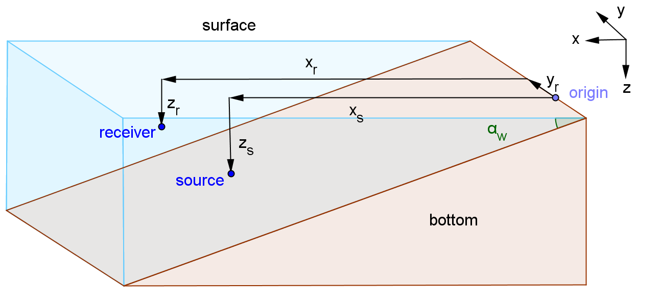

Figure 1 – Acoustic transmission loss geometry for 3-D wedge

Using the method of images, we assume that each reflection gives rise to a source image, and that these images lie on a circle centered on the apex of the wedge. This derivation is very similar to the Deane/Buckingham model defined in reference [1], but it simplifies that model by assuming that interface reflection coefficients are limited to $±1$. Figure 2 is a cross-slope view of the 3-D wedge showing each of the image sources and each virtual interface. In this illustration, surface interfaces are shown with a dashed line, bottom interfaces are shown with a dot-dashed line, and source images are shown as dots along the circumference of a circle whose radius defined by the original distance of the source from the apex.

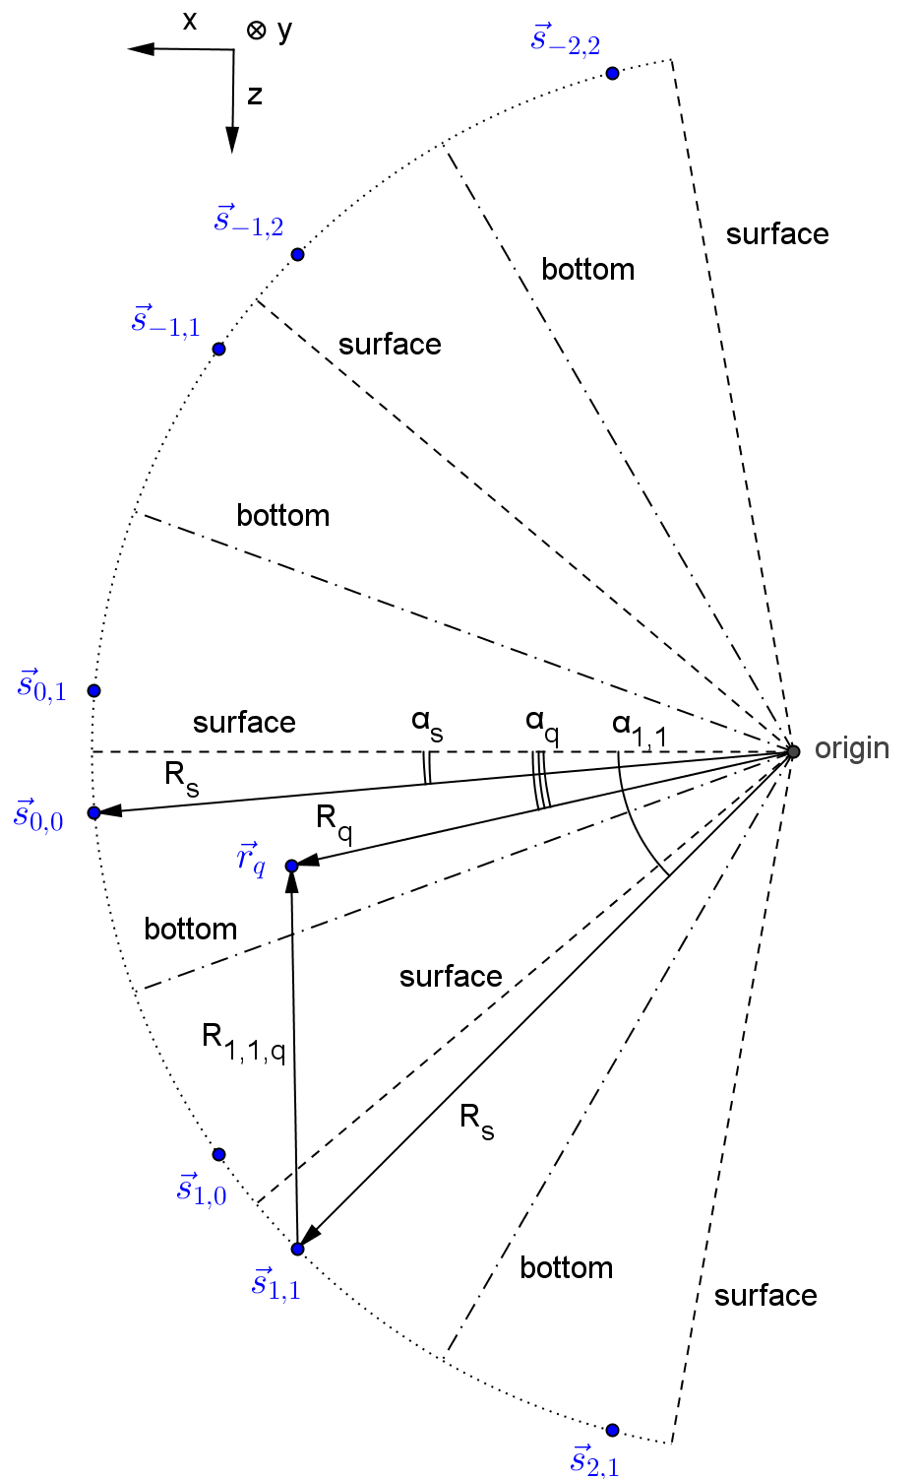

Figure 2 – Geometry for method of images in a 3-D wedge

The complex pressure at each receiver location is a sum of spherical wave contributions from each source image. If we assume that the reflection coefficient is +1 at the bottom and -1 at the surface, this takes the form:

|  |  |  |
| --- | --- | --- |
|  | $$p_{q}=\sum_{n=-n_{max}}^{n_{max}}{\sum_{m=n-1}^{n}{{\left(-1\right)}^{m}\frac{e^{ikR_{n,m,q}}}{R_{n,m,q}}}}$$ | (1) |

where

$n$ = number of bottom reflections for source image, negative if above surface;

$m$ = number of surface reflections for source image, negative if above surface;

$n_{max}$ = maximum number of bottom bounces;

${\vec{s}}_{n,m}$ = location of each source image;

$q$ = index number for each receiver;

${\vec{r}}_{q}$ = location of each receiver;

$R_{n,m,q}$ = slant range from each source image to each receiver;

$c$ = speed of sound in water;

$f$ = signal frequency;

$k$ = acoustic wave number $={2πf}/c$; and

$p_{q}$ = total complex pressure for each receiver.

To compute $R_{n,m,q}$, reference [1] defines a cylindrical coordinate system whose axis travels along the wedge apex:

$R_{s}$ = slant range of original source from the wedge apex;

$α_{s}$ = angle of original source down from the ocean surface;

$α_{n,m}$ = angle of each source image, relative to the ocean surface, negative if above surface;

$R_{q}$ = slant range of each receiver from the wedge apex;

$α_{q}$ = angle of each receiver down from the ocean surface; and

$y_{q}$ = cross-slope distance of each receiver relative the vertical source/origin plane.

An inspection of the geometry in Figure 2 allow us to compute $α_{n,m}$ and $R_{n,m,q}$ for the 3-D wedge.

|  |  |  |
| --- | --- | --- |
|  | $$α_{n,m}=2nα_{w}+{\left(-1\right)}^{n+m}α_{s}$$ | (2) |

|  |  |  |
| --- | --- | --- |
|  |  | (3) |

Source images outside of the range $α_{n,m}∈\left[-π,π\right]$ result in “imaginary” images that contribute to the diffracted component of the acoustic field. Reference [1] states that for small wedge angles and locations far from the apex, the diffracted components are negligible and need not be considered.

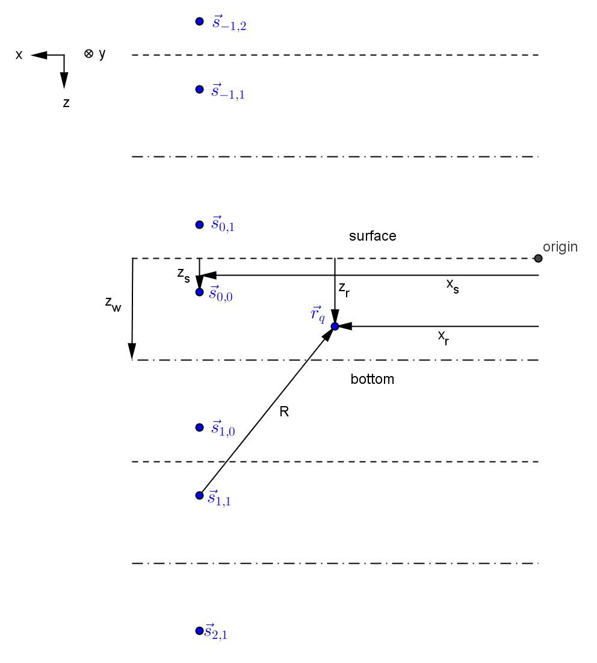

Figure 3 – Method of images for flat bottom

An equivalent solution for an environment of constant depth are derived by inspection of Figure 3.

|  |  |  |
| --- | --- | --- |
|  | $$z_{n,m}=2nz_{w}+{\left(-1\right)}^{n+m}z_{s}$$ | (4) |

|  |  |  |
| --- | --- | --- |
|  |  | (5) |

where

$x_{s}, z_{s}$ = range and depth of original source relative to ocean surface;

$x_{q}, z_{q}$ = range and depth of each receiver relative to ocean surface;

$y_{q}$ = cross-slope distance of the receiver relative the vertical source/origin plane;

$z_{n,m}$ = depth of each source image;

$z_{w}$ = water depth;

Figure 4 compares the analytic solutions for a simplified version of the ASA wedge benchmark [2], to an equivalent 2-D environment of constant depth. To support later comparisons to WaveQ3D, Figure 4 includes results both at the 25 Hz frequency specified by the ASA wedge benchmark, and 2000 Hz, a frequency more appropriate to Gaussian beam ray theory.

= 2.86o

= 4000 meters

$z_{s}=z_{r}$ = 100 meters

$z_{w}$ = 200 meters

$c$ = 1500 m/s



Figure 4 – Analytic solutions for small wedge angle

Figure 5 provides a similar comparison for wide angle benchmark from reference [1]. Note that the cross range axis in Figure 5 only extends to 10 km, while the axis in Figure 4 extends to 70 km.

= 21o

= 520 meters

$z_{s}=z_{r}$ = 100 meters

$z_{w}$ = 200 meters

$c$ = 1500 m/s



Figure 5 – Analytic solutions for wide wedge angle

In both Figure 4 and Figure 5, the 3-D wedge has significantly stronger losses as a function of cross slope range than predicted by an equivalent 2-D model. The physical interpretation of this phenomena is that the 3-D wedge turns high angle paths toward deep water so that they fail to contribute to the received level at longer ranges. At some cutoff range, the 3-D propagation is reduced to a combination of the direct and surface reflected paths, and the transmission loss takes on the characteristics of a Llyod’s Mirror scenario. This cut-off range decreases as the wedge angle increases. Because the 2-D constant depth solution does not reject higher angle paths, it exhibits less transmission loss. In the next section, this difference is used as a benchmark to demonstrate 3-D transmission loss effects in the WaveQ3D model.

# WaveQ3D comparisons to analytic solutions

Because the WaveQ3D calculations are performed in geodetic coordinates, the simple wedge used in our analytic solution can only be approximated in WaveQ3D. On a round Earth, an interface with constant slope is a curved surface instead of a plane. To minimize the impact of this curvature, the wide wedge angle scenario is used to shorten the range over which 3-D effects can be observed. The source and receivers are placed at a depth of 100 meters at the Equator. The water depth at this point is set to 200 meters and the bottom slope is a constant 21o, sloping down to the north, at all latitudes and longitudes. This definition orients the wedge illustration in Figure 1 such that the x-direction is north, the y-direction is east, and the z-direction is down. Receivers are placed east of the source, along the y-direction, at varying cross slope ranges.



Figure 6 – Top down view of ray path horizontal slice through -10o D/E

Figure 6 illustrates the propagation of the WaveQ3D ray paths in this scenario. It provides a top down view of a horizontal slice through the wavefront for ray paths launched with a depression/elevation angle of -10o (down) and azimuths from 75o to 175o. The solid lines represent the ray paths. The dotted lines represent the time evolution of the wavefront out to 1.5 s in 0.1 s increments. The wedge apex is located 520 m south of this line of receivers and the wedge slopes down to the north. Rays traveling up the wedge encounter a steep slope along the path of travel and they are strongly turned in the downslope direction. Rays traveling along the slope, and are not turned as sharply.



Figure – Top down view of ray path vertical slice through 135o AZ

Figure 7 provides a top down view of a vertical slice through the wavefront for ray path at an azimuth angle of 135o (south east) and depression/elevation angle from 0o to -60o (down). Each time that a ray collides with the wedge, it is turned down slope. Rays launched at steeper angles encounter the bottom sooner, and are turned down the slope earlier.

Figure 6 and Figure 7 provide a ray theory interpretation of the cut-off range seen in the analytic solution; any paths that interact with the bottom are turned down slope and soon fail to contribute to the received level for long range targets. Although this phenomena is often referred to as horizontal refraction, this turning is actually a reflection process and it only occurs at the discreet locations where the ray interactions with the bottom.



Figure 8 – Coherent comparison to analytic solutions



Figure 9 - Incoherent comparison to analytic solutions

Figure 8 and Figure 9 compare the WaveQ3D results to the analytic solutions for the flat bottom and wedge analytic solutions. Figure 8 illustrates the coherent solution computed by Eqn. (1); Figure 9 compares the incoherent solutions. In both cases, the WaveQ3D result supports result predicted by the analytic solution for the 3-D wedge. The analytic solution for a simple 3-D wedge provides the testing benchmark needed to clearly demonstrate 3-D effects in WaveQ3D transmission loss.

# Works Cited

|  |  |
| --- | --- |
| [1] | G. B. Deane and M. Buckingham, "An analysis of the three-dimensional sound field in a penetrable wedge with a stratified fluid or elastic basement," *J. Acoust. Soc. Am.,* vol. 93, no. 3, pp. 1319-1328, March 1993. |
| [2] | F. B. Jensen and C. M. Ferla, "Numerical solutions of range‐dependent benchmark problems in ocean acoustics," *J. Acoust. Soc. Am.,* vol. 87, no. 4, pp. 1499-1510, 1990. |